Downloading Cisco packet tracer exe file for windows 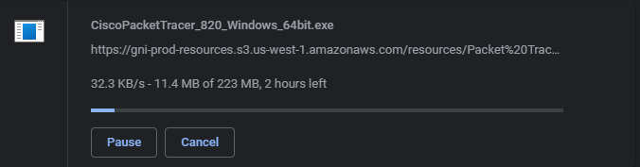

Step 1:-After cisco packet tracer download click on the downloaded exe file window will appear choose the next option

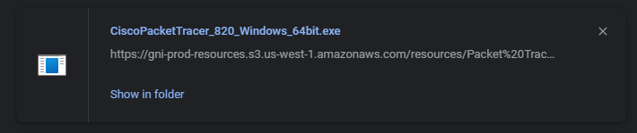

Step2:-Select I accept the agreement and click one the next

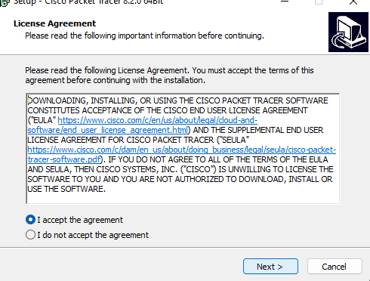

Step3:- Setup will show the folder in which the cisco packet tracer.

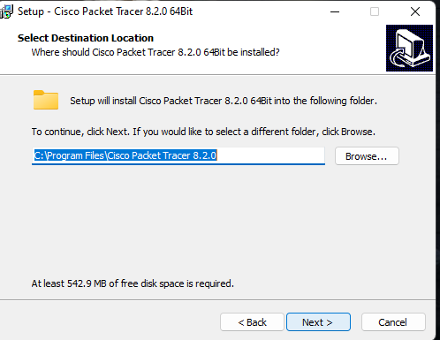

Step4:-Program will ask for shortcut to be created.

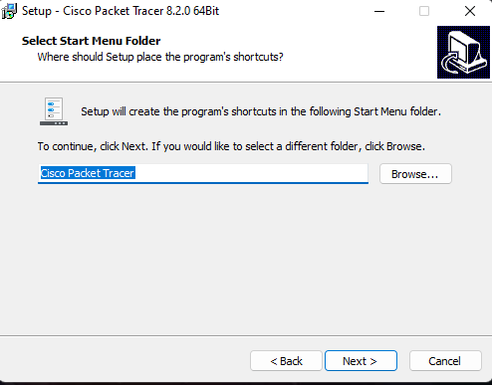

Step5:-It will ask to create a desktop shortcut and to create a quick launch shortcut after selecting the option click on next button.

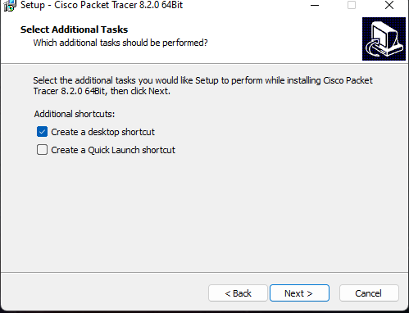\

Step6:-Setup is ready to install packet tracer 8.2.0 version on the computer select install button.

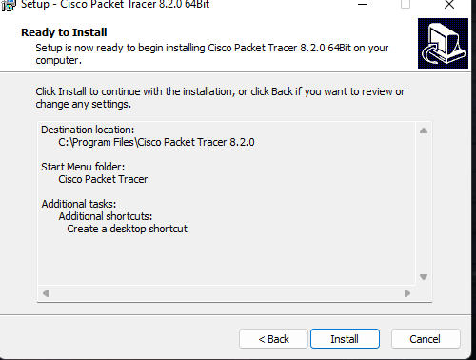

Step7:-Setup installs cisco packet tracer on computer.
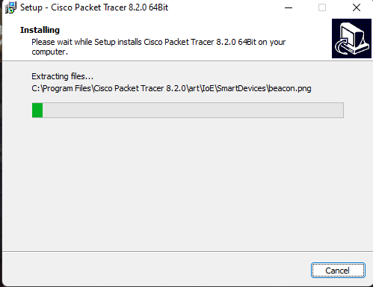

Step8:-Setup has finished installing the cisco packet tracer.

